***Plan of Approach***

**Tim Verhees**

*02-09-2022   
V0.1*

# **Versions**

|  |  |  |
| --- | --- | --- |
| **Datum** | **Versie** | **Omschrijving wijziging** |
| **02-09-2022** | 0.1 | Initial version |
| **06-09-2022** | 0.2 | Second version, still a work in progress |

# **Distributionlist**

|  |  |  |  |
| --- | --- | --- | --- |
| **Datum** | **Versie** | **Naam** | **Functie** |
|  |  | Tim Verhees |  |
|  |  |  |  |

**Table of contents**

**Versionlist** 2

**Distributionlist** 2

**1.** **Introduction** 4

**2.** **Objective** 4

**3.** **Assignment description** 4

**4.** **Conditions and starting points** 4

**5.** **Critical Succesfactors** 5

**6.** **Products to be delivered** 5

**7.** **Aanpak** 6

**8.** **Planning** 7

**9.** **Projectorganisatie** 8

**10.** **Risicoanalyse** 8

**11.** **Communicatie** 10

**12.** **Verwijzingen** 11

# **Introduction**

Yu-gi-oh is a trading card game made by Konami following the popular kids cartoon Yu-Gi-Oh. It was released in 1999 and was an instant hit. In the years to follow Konami would release set after set of cards containing new monsters, spells, traps, etc. With such attention the game was pushed to grow and grow. Looking back today, the game has evolved significantly, and so did the people playing it. More and more players became more and more serious about the game, creating a competitive scene for the game. This required that Konami would address some of the cards that were deemed an issue.

This was the birth of the “Ban List”. A list consisting of all the cards not allowed to be used in regular and competitive play. This list includes cards that can only be used twice or once, instead of the regular three times and even cards that are outright forbidden. This list is changed every once in a while, cards getting added to it, removed from it. However one thing remains relatively absolute. You have to abide by this list. Some players though, feel that the list is not accurate enough in accordance with the current state of the competitive scene.

# **Objective**

With this project I aim to create a simple program that would allow users to construct their own “Ban List”. In this program regular users can create their own ban lists and admins will be able to add new sets to the list of available cards as the game evolves.

# **Assignment description**

The assignment is to create an application that applies several learning outcomes presented by Fontys. It has to include several elements we learn throughout semester 3, an example of which is the usage of a RESTful API.

# **Conditions and starting points**

1. Conditions
2. The deadline for the project is week 20 of the semester;
3. The project is to be delivered on Canvas;
4. The products delivered will only be realised by the student;[1]
5. The project must abide by the learning outcomes and show progress in those areas.
6. Starting points
7. The student follows the planning of the semester and the project without defects;
8. Both the coach and the teachers will, at several points throughout the semester, be available for questions, feedback and general advice regarding the project;

# **Critical Succesfactors**

Here are some of the factors that could be seen as critical for a successful completion of the project:

1. The student actively seeks help and feedback regarding points of concern and/or difficulty with the project.
2. Everything needs to be documented according to both the school’s guidelines and in a way that the choices made throughout the project are documented and backed up.
3. There needs to be a concise planning on what is going to be performed when, for example what is going to be realised during the first, second and third sprint.
4. The coaches and teacher need to be available for feedback and help.
5. At the end of the project there needs to be back-end and front-end application that fills the most important requirements.

# **Products to be delivered**

These are the products that are to be delivered at the end of the deadline. Not all products share the same deadline.

|  |  |
| --- | --- |
| Product | Opleveren aan |
| Plan of Approach | Jacco & Maja & Ali |
| Product Backlog | Jacco & Maja & Ali |
| Prioritization | Jacco & Maja & Ali |
| Estimation | Jacco & Maja & Ali |
| Acceptance | Jacco & Maja & Ali |
| Proof of Concept | Jacco & Maja & Ali |

# **Approach**

As per the requirements of this semester, I will be working in an Agile method. I will be utilizing sprints to iterate my front-end and back-end applications. There are some documents, like this one for instance, that will be universally applicable, and so will only be made once. However others, like requirements and prioritization, will be made in accordance with the current sprints goal.

Below is a visual representation of how these sprints will look and function.

Source: <https://blogs.gladwellacademy.com/nl/waarom-de-sprint-planning-onmisbaar-is>

I will also keep a planning on the website called Trello. Here I can keep track of what needs to be done, what is currently being worked on and what is finished.

# **Planning**

As mentioned before my planning will be made in a third party website called Trello, an example of how that planning will look like is this. 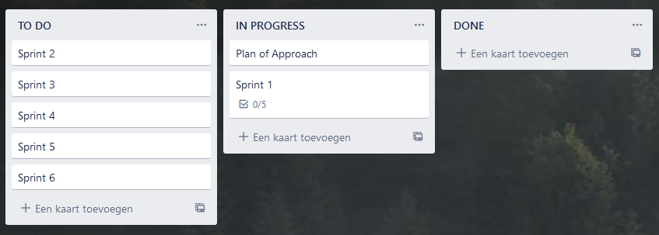

# **Projectorganisation**

Within this project there are a few roles that come into play.

|  |  |  |
| --- | --- | --- |
| Role | Name | Responsibilities |
| **Project Handler** | Tim Verhees | This is the person who makes the project. They are responsible for documentation, realisation and argumentation for the project. |
| **Technical Teachers** | Jacco Snoeren, Maja Pesic | These are the technical teachers that will teach some of the concepts applied in the applications. They will also be available to help the project handler if they have questions and provide feedback on the progress of the project. |
| **Semester Coach** | Ali Odaci | The semester coach helps the project handler along the path of the project, giving them pointers in regards to any difficulties during the project. They will also provide general information in regards to future semesters. |

# **Risk analysis**

# **Communicatie**

# **Verwijzingen**

1. It is however possible for the student to ask questions to their coach and technical teachers